**4.System Design:**

* 1. **System Architecture:**
  2. **User Interface Design :**

The concept of our website user interface design was based on user-friendliness, easy to used features, not many levels of clicking, and the website are attractive with an image and icons for the subjects.



**HOME :**

The main page of our website that contains button bar include ( Home , About Us , FAQs , Sign Up , Sign In ) and contains multiple images and icons for the subjects and there is a search box to search for specific subjects.

Also, it contains in below the page ( contact with us )

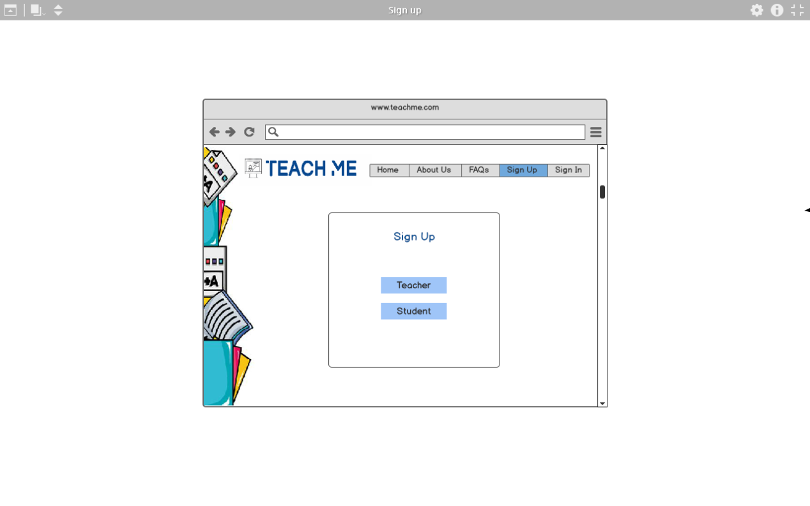

**SIGN UP:**

The user must choose if he/she wants to sign up as a teacher or as a student.

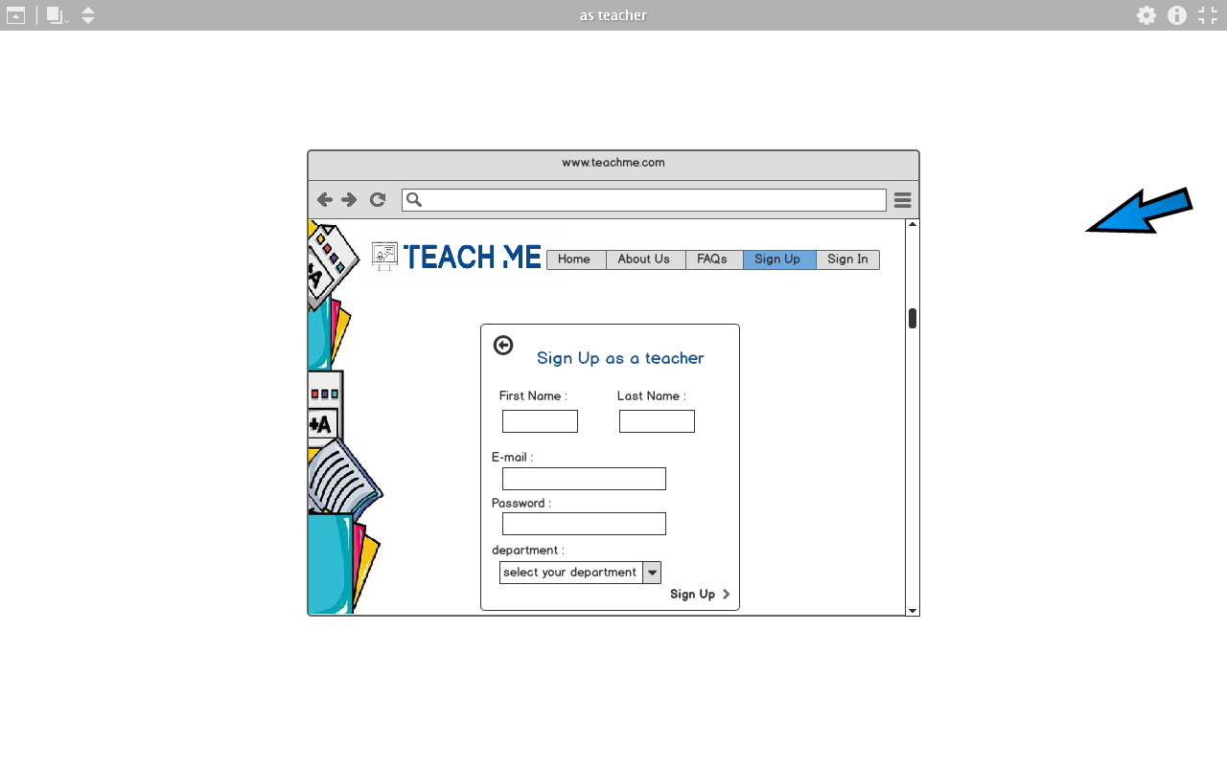

**SIGN UP AS TEACHER :**

Enter the required information to register to the website as a teacher such as first name, last name, password, and chose from the checklist his/her department.

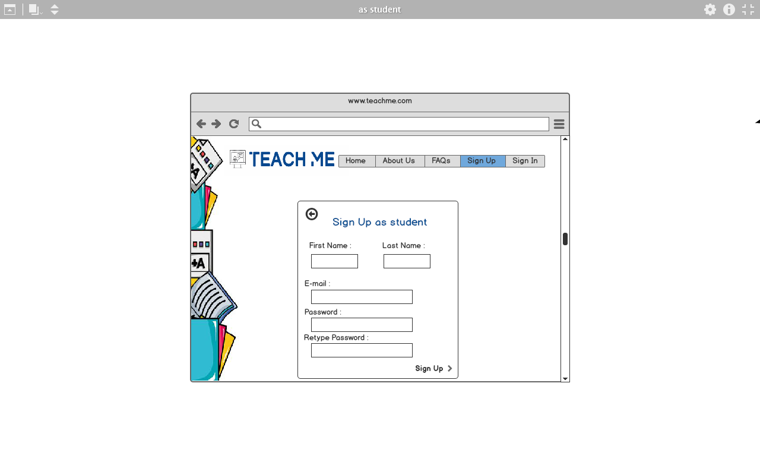

**SIGN UP AS STUDENT :**

Enter the required information to register to the website as a student such as first name, last name, password, confirm password.

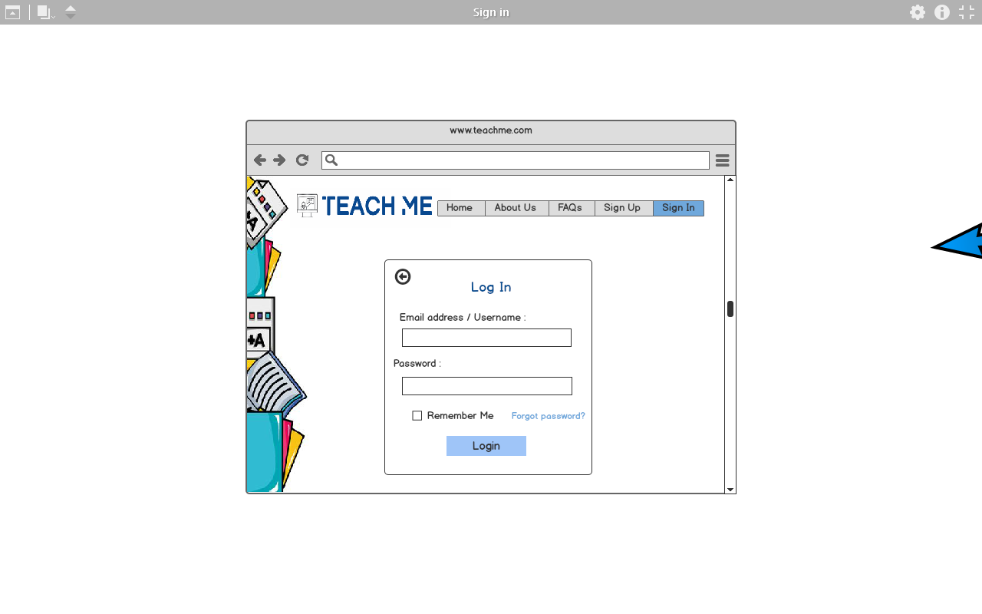

**SIGN IN :**

login to the website using the Email address or username and password.